Company Details
Company Name
Brief Description of Service

Data Protection Supplier Questionnaire
ICO Registration
Are you ICO Registered? | ​☐ Yes  ☐ No
ICO Registration Number
If you are not ICO registered, are you registered in another country? If yes, please provide details.
In the last 12 months have you been subject to any enforcement action from the ICO (or applicable regulator)? | ​☐ Yes  ☐ No  ☐ Pending Notification
Are you ICO Registered? | ​☐ Yes  ☐ No

Data Protection Officer
Do you have a dedicated DPO or designating individual who has responsibility for monitoring compliance with data protection? | ​☐ Yes  ☐ No
If yes, please provide name and contact details.

Records Retention
Please describe the retention policies you have in place.
When records have been destroyed, are you able to provide proof of destruction? e.g, signed email confirmation, certificate of destruction, etc. | ☐ Yes  ☐ No
Please provide details of any processes you have in place to provide proof of destruction.

Relationship
What is your expected data protection relationship with the IOPC? | ​☐ Controller to Controller  ☐ Joint Controller  ​☐ Controller (IOPC) to Processor (You)  ☐ Controller (You) to Processor (IOPC)
If multiple relationships apply for different data types, please explain.

Suppliers, Sub-Processors and Third Parties
Will the main supplier be acting as a data processor or a data controller? | ☐ Processor  ☐ Controller
Will any sub-processors or third parties be processing personal data that the IOPC has provided to you? | ​☐ Yes  ☐ No
If yes, please specify data to be processed and purpose of processing.
If yes, do all sub-processors or third parties have Article 28 compliant contracts? | ​☐ Yes  ☐ No

International Transfers
Will any IOPC data be processed outside of the UK? | ​☐ Yes  ☐ No
If yes, please detail the processing undertaken in each jurisdiction.
Will any IOPC data be processed outside of the EEA? | ​☐ Yes  ☐ No
If yes, please detail the processing undertaken in each jurisdiction and the adequacy agreement you rely on.

Data Breaches
Do you have a documented Data Breach Policy? | ​☐ Yes  ☐ No:  ☐ Other (please specify):
Do you have an incident/data breach management framework in place? | ​☐ Yes  ☐ No:  ☐ Other (please specify):
Do you have mechanisms or processes in place for identifying a personal data breach? | ​☐ Yes  ☐ No:  ☐ Other (please specify):
Do you have processes or guidance in place for assessment as to the level of risk created by a breach? | ​☐ Yes  ☐ No:  ☐ Other (please specify):
Have you tested your Data Breach Response and was this successful? | ​☐ Yes  ☐ No:  ☐ Other (please specify):
Do you have the necessary expertise to assist the IOPC with enquiries and actions in the case of a personal data breach stemming from your organisation? | ​☐ Yes  ☐ No:  ☐ Other (please specify):
Do you have a process(es) for regularly testing, assessing, and evaluating your technical measures for ensuring the security of processing? Please give details of such process(es). | ​☐ Yes  ☐ No:  ☐ Details (please specify):
Do you have a process(es) for regularly testing, assessing, and evaluating your organisational measures for ensuring the security of processing? Please give details of such process(es). | ​☐ Yes  ☐ No:  ☐ Details (please specify):

Data Storage
Please provide details on how you securely store your physical/digital records.

Data Sharing
Do you have any data sharing agreements already in place or in addition to the contract being agreed? | ☐ Yes  ☐ No
If yes, please confirm that the data sharing agreement contains the following:  • the obligation to record decisions, particularly in relation to the transfer or destruction of information.  • obligations under copyright, data protection legislation and FOIA.  • record management controls and any specific requirements for the security and handling of personal information. | ☐ Yes  ☐ No, please provide further details:
With direction from the IOPC, are you aware and do you agree to that if IOPC information reaches the end of its retention period before the end of the contract you will be required to dispose of it? | ☐ Yes  ☐ No

Assisting the IOPC
Do you have sufficient processes in place to assist the IOPC in complying with data subject rights requests?

Digital Continuity
Please describe the digital continuity policies you have in place.

Training and Awareness
Please detail data protection or related security training undertaken by staff who will be processing IOPC data.

Completion
Name:
Role:

Signature:

Date:

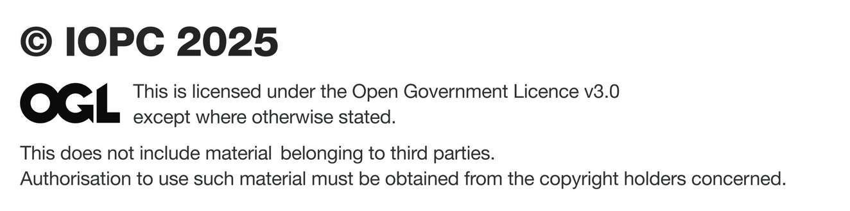
Published December 2025

To find out more about our work or to request this report
in an alternative format, you can contact us in a number of ways:

Independent Office for Police Conduct (IOPC)
10 South Colonnade Canary Wharf London E14 4PU
Tel: 0300 020 0096
Email: enquiries@policeconduct.gov.uk
Website: www.policeconduct.gov.uk
Text relay: 18001 020 8104 1220

We welcome telephone calls in Welsh
Rydym yn croesawu galwadau ffôn yn y Gymraeg

